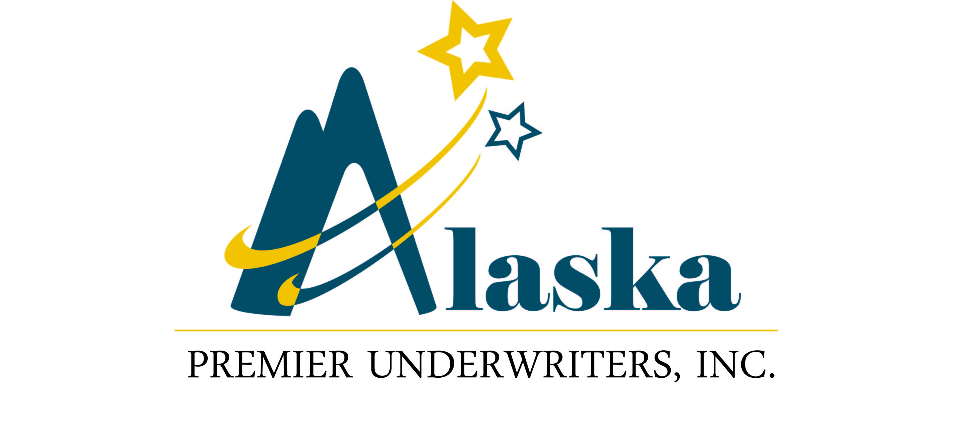

Privacy Policy Notice
The non-public personal information that Alaska Premier Underwriters, Inc. collects on you is limited to information we receive from the application materials you complete to obtain insurance coverage with the company.
Alaska Premier Underwriters, Inc. does not disclose any non-public personal information about our customers to anyone except as outlined, above or is permitted by law.
Alaska Premier Underwriters, Inc. restricts access to non-public personal information about you to those employees who need to know that information to provide services to you.
Alaska Premier Underwriters, Inc. may accumulate information from consumer reporting agencies, public records and data collection agencies, in addition to your application for insurance with such information containing your name, address, telephone number, age insurance coverage, transaction history, claims history and premiums paid.
Alaska Premier Underwriters, Inc. may collect information as we deem appropriate to determine eligibly for coverage, to process claims, to prevent fraud, and is authorized by you or is otherwise permitted or required by law.
Alaska Premier Underwriters, Inc. reserves the right to modify or supplement this Privacy Policy at any time. If we make material changes, we will provide current customers with a revised notice that describes our new practices.
Cordially,
LISA M. WOODALL
President

AKPU0004(07/2012)

